HD 156279

HD 156279 is a 0.93 M☉, K0 star1. Based on 87 RV HIRES measurements obtained between 2003 and 2019, the CL survey reported a GP (HD 156279b) with a period of 133.403 ± 0.004 days, a minimum mass of 9.5 ± 0.31 MJup and an eccentricity of as well as a LPGP (HD 156279c) with a period of days, a minimum mass of MJup and an eccentricity of .

In the present study, in addition to the CL survey’s dataset, 3 RV ELODIE measurements obtained between 2005 and 2006 and 15 RV SOPHIE measurements obtained between 2010 and 2011 were used. DPASS and MCMC (1000 walkers and 300000 iterations) were used to fit the data. The properties found for planets HD 156279 b and c reported in the CL survey were within the error bars associated with the values found in the present analysis. The fits are shown in Fig 1, and the corner plot in Fig 2, and the results summarized in Table 1.

Note that, recently, combining RV and Hipparcos/Gaia absolute astrometry data, a study performed in 20222 reported, for HD 156279b, properties close to those reported in the CL survey and were able to estimate the orbital inclination, and thus the true mass, of HD 156279c. They found a period of days, an eccentricity of 0.261 ± 0.006, an inclination of °, and a mass of MJup.

Conclusion: The properties found in the CL survey for both planets are confirmed.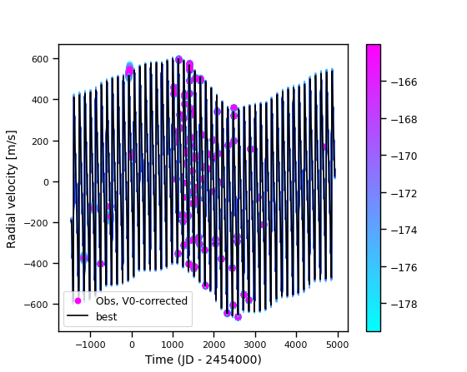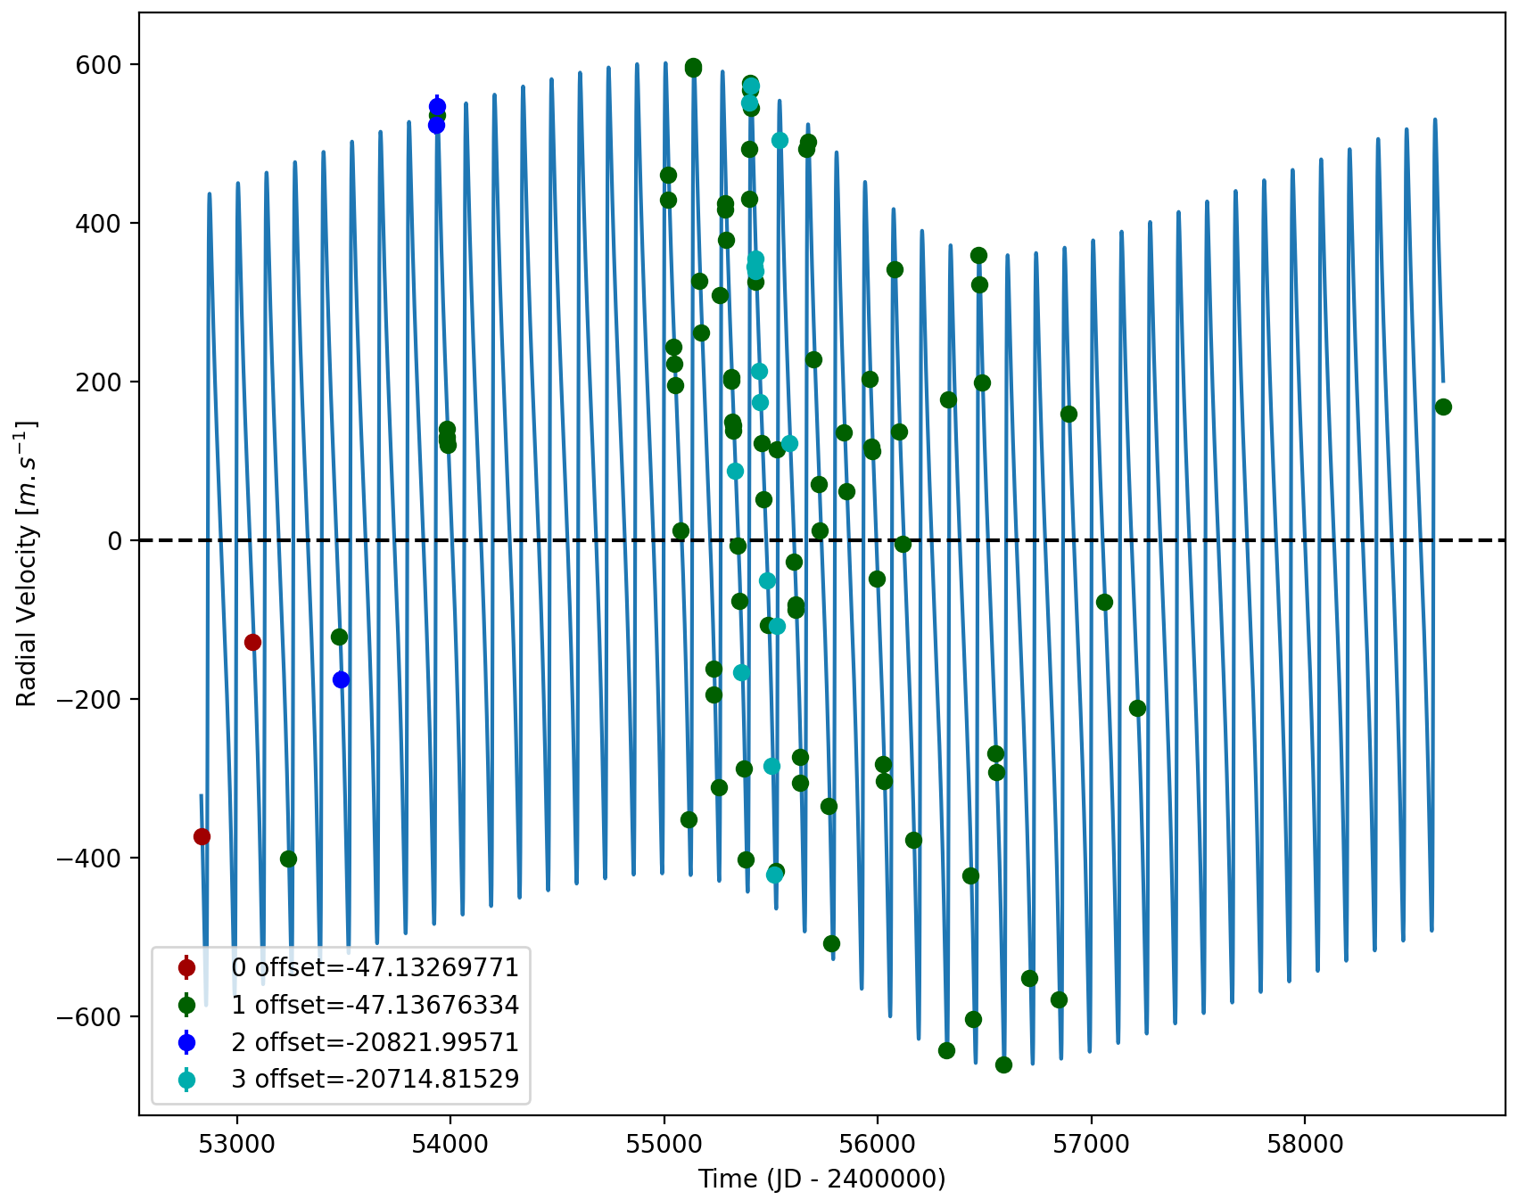

Figure 1: Left: fit of the HD 156279 RV with DPASS. Red - Hir94, green - Hir04, blue - ELODIE, cyan - SOPHIE. The blue curve shows the best fit. Right: fit of the HD 156279 RV using MCMC. The black curve shows the best fit. The colorbar corresponds to the log-likelihood of the fits.

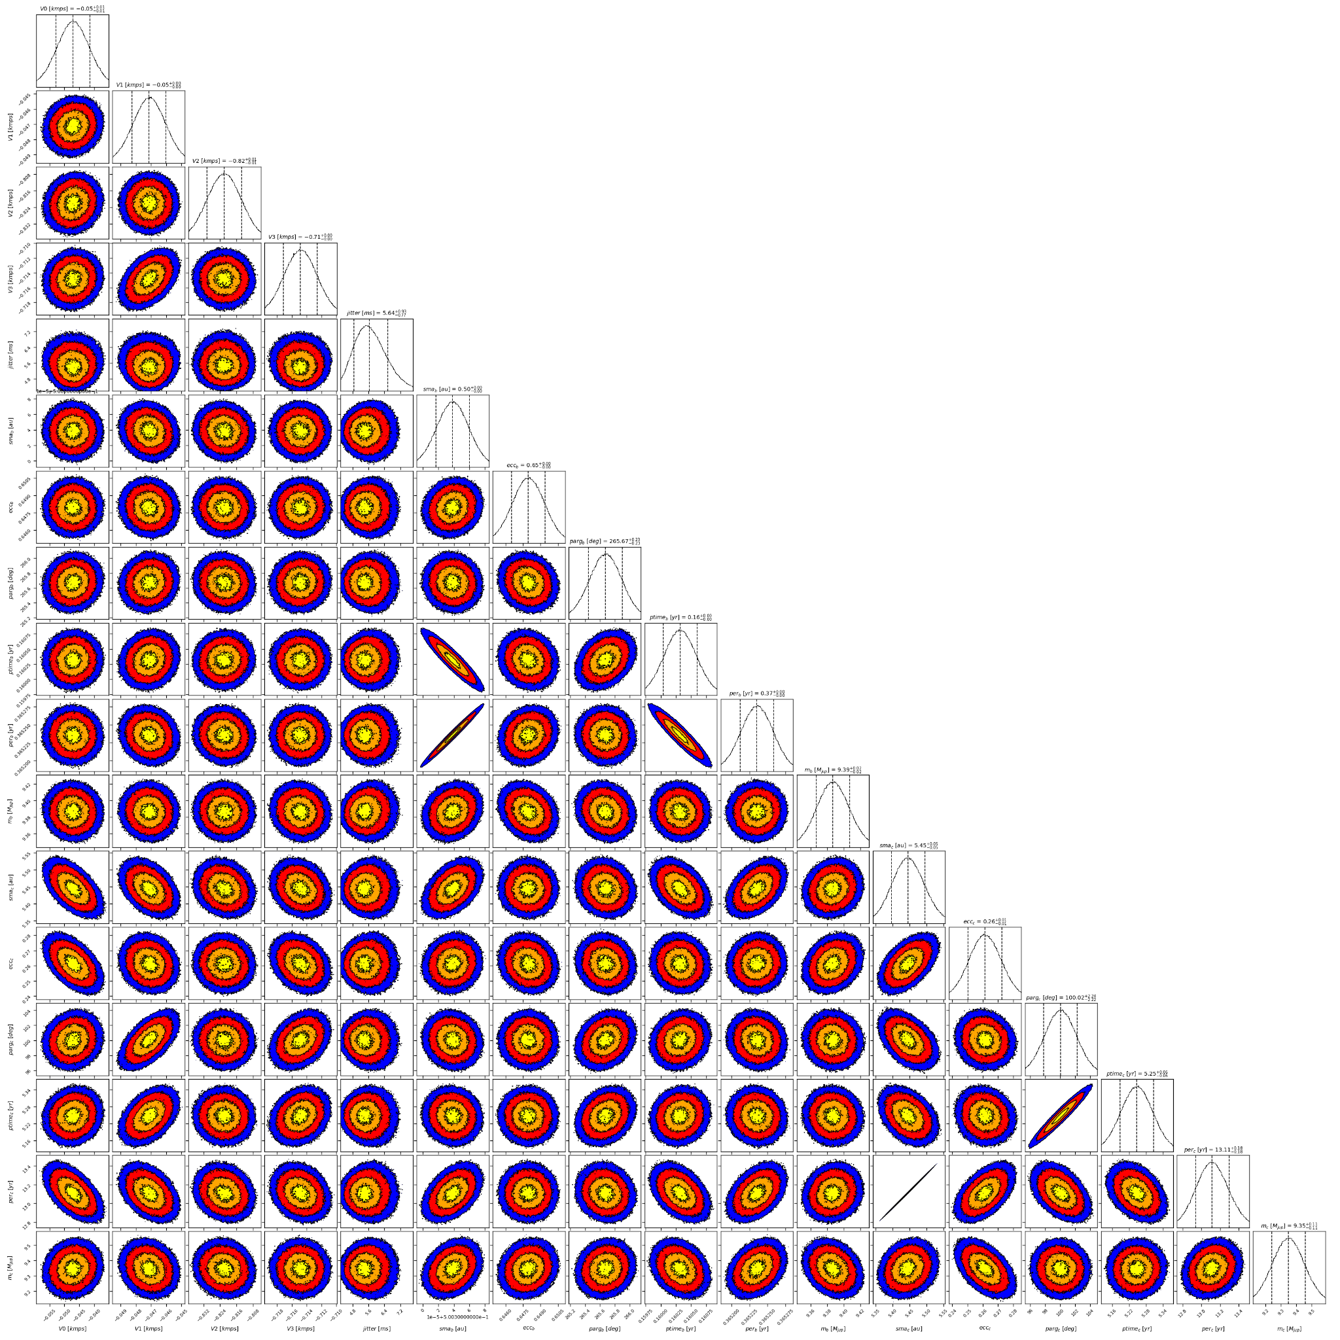

Figure 2: Corner plot of posteriors for the two-planets model MCMC fit of HD 156279 RV data.

| Parameter | Priors | | Posteriors | | CL survey |
| --- | --- | --- | --- | --- | --- |
|  | DPASS | MCMC | DPASS | MCMC |  |
| *a* (au) | b: [0,100]  c: [0,100] | b: [0.1,1]  c: [1,10] | b = 0.5  c = 5.4 | b = 0.50 ± 0.01  c = 5.45 ± 0.05 | b =  c = |
| Msin(i) (MJup) | b: [0,100]  c: [0:100] | b: [1,20]  c: [1,20] | b = 9.38  c = 9.3 | b = 9.39 ± 0.02  c = 9.3 ± 0.1 | b = 9.5 ± 0.31  c = |
| Eccentricity | b: [0,0.95]  c: [0,0.95] | b: [0,0.9]  c: [0,0.9] | b = 0.65  c = 0.26 | b = 0.65 ± 0.01  c = 0.26 ± 0.01 | b =  c = |
| Instrumentals offsets (km/s) | [-60,60] | Hir94: [-1,1]  Hir04: [-1,1]  ELODIE: [-21,-19]  SOPHIE: [-21,-19] | Hir94: -0.047  Hir04: -0.047  ELODIE: -20.822  SOPHIE: -20.715 | Hir94: -0.047 ± 0.006  Hir04: -0.047 ± 0.001  ELODIE: -  SOPHIE: -20.715 ± 0.002 |  |
| Stellar jitter (m/s) | [0,40] | [0,20] | 4.3 |  |  |
| Argument of periastron (°) | b: [0,360]  c: [0,360] | b: [0,360]  c: [0,360] | b = 266  c = 100 | b = 265 ± 1  c = 100 ± 2 |  |
| Phase | b: [0,1]  c: [0,1] | b: [0,1]  c: [0,1] | b = 0.27  c = 0.73 | b = 0.44 ± 0.01  c = 0.40 ± 0.01 |  |

Table 1: HD 156279. Summary of priors and posteriors obtained with DPASS and MCMC, compared to the properties reported by the CL Survey.

References

1. Diaz, R. et al. The SOPHIE search for northern extrasolar planets IV. Massive companions in the planet-brown dwarf boundary. *Astron. Astrophys.* 538, A113 (2012).
2. Feng, F. et al. 3D Selection of 167 Substellar Companions to Nearby Stars. *Astrophys. J. Supp. Ser.* 262, 21 (2022).